Pulse oximetry to detect early deterioration of patients with COVID-19 in primary and community care settings

About your illness
You have a viral illness, which for most people will be relatively mild, but which can become serious, sometimes quickly. Mainly, we are concerned by any signs that your breathing is getting worse. Some other symptoms, such as fever, cough, muscle aches, tiredness, mild chest pain and change in taste or smell are less worrying, and most people will get better by themselves within 2-3 weeks. Some people with Covid-19 infection may develop other problems.

To find out more visit www.patient.info/coronavirus-covid-19

Why are you being monitored?
The reason why we are asking you to monitor your oxygen level is because this helps us to assess Covid-19 related symptoms and identify whether you need oxygen which will require hospital treatment.

How long will you be monitored for?
We will be monitoring you for 14 days.

Pulse oximeter for heart rate and blood oxygen level

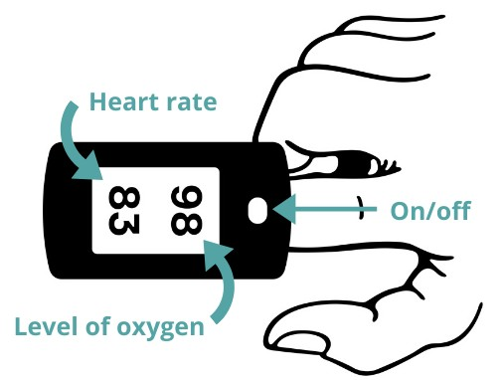
Your doctor has given you, or your carer, this diary and pulse oximeter because you have symptoms of COVID-19. A pulse oximeter helps you monitor how fast your heart is beating and the level of oxygen in your blood. Blood oxygen level is the most accurate way of keeping an eye on your progress with COVID-19. An
ideal blood oxygen level is between 95% and 99%. An ideal heart rate is between 50 and 90 beats per minute (bpm).

How to use a pulse oximeter

Follow these instructions to make sure the pulse oximeter gives an accurate reading (image to right courtesy of Denis Barbulat):

- Remove any nail polish or false nails and warm your hand if cold.
- Make sure you have been resting for at least five minutes before taking your measurement.
- Rest your hand on your chest at heart level and hold still.
- Switch the pulse oximeter on and place it on your finger. It works best on your middle or index finger (see diagram). It should not be used on your ear.

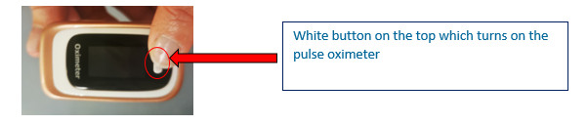
- The reading takes time to steady. Keep the pulse oximeter in place for at least a minute, or longer if the reading keeps changing.

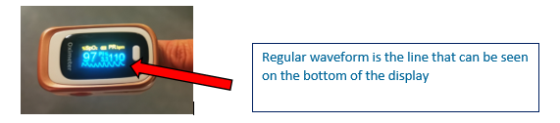

- Record the highest result once the reading has not changed for five seconds.
- Be careful to identify which reading is your heart rate and which is your oxygen level.

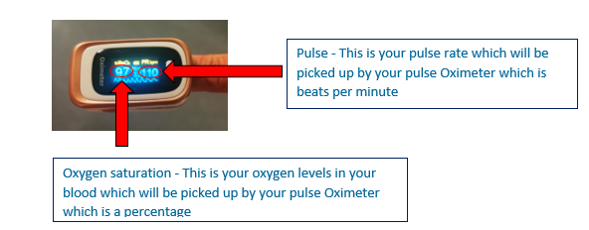

You may find the following Youtube video a useful resource to understand how to safely use the pulse oximeter:

https://www.youtube.com/watch?v=jAeZVIAQ2sQ&feature=youtu.be

Recording and acting on the results

Record your results in the paper diary that you have been provided.

Your first measurement is your baseline – so record this in the highlighted blue area. Then take recordings three times a day, at the same time each day (9am, 12.30pm and 3.30pm). Take extra measurements if you feel there has been a change in your health. Please also record changes in how you are feeling and your breathing.

Keep track of your temperature if you can.

Temperature – Please take your temperature using your own home thermometer (if you have one).

Breathing – Count how many times you take a breath in a minute which is one count for breathing in and out.

Feeling Worse/Same/Better – This is your overall sense of how well or unwell you are feeling compared to yesterday. This could be that you feel weaker, more breathless, and lightheaded, or if you develop new symptoms i.e. diarrhoea, vomiting, stopping urinating and chest pains.

You will either receive a SMS text message from a system called AccuRx asking you to complete a survey or someone from the Dorset Healthcare Telehealth team will telephone you (as confirmed to you when you are issued the pulse oximeter). This is being used to collect the data you record within your patient diary, three times a day. It is important that you respond to this survey as this is how the clinical teams will be able to monitor and respond to any changes in your condition between 9am-5pm, Monday-Sunday. The monitoring team will contact you if they have any concerns during this time.

This is how your SMS text message will look if you have agreed to have your data collected via AccuRx text messaging:

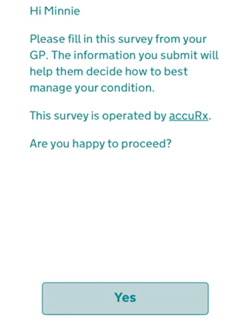

As long as your oxygen level and breathing are normal, you do not need to contact your GP/NHS 111 if you have a temperature or other symptoms, such as cough, muscle aches, tiredness and change in taste or smell. Paracetamol and regular fluids can help with these symptoms, and most people will get better by themselves within two to three weeks. Please see the NHS website for information on self-isolation or how to access care.

What to do if you experience the following symptoms

- you feel cold and sweaty with pale or blotchy skin
- you have a rash that does not fade when you roll a glass over it
- you collapse or faint
- you become agitated, confused or very drowsy
- you have stopped peeing or are peeing much less than usual

If you begin to feel worse throughout the day between 9am-5pm, Monday-Friday please call your GP Practice; below is guidance on when to call:

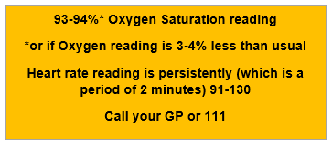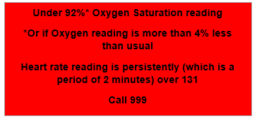

If you feel worse during the evening/night from 5pm until 9am please refer to the guidance below on what to do:

Returning the pulse oximeter

When you no longer need the device, please return it to wherever you were issued it. If the device was delivered to your home, the Telehealth monitoring team will arrange for collection from a NHS volunteer.

- Please wash your hands with soap and water
- Clean the pulse oximeter with an antibacterial wipe
- Put in a clean bag clearly marked with your name and address.

If you are shielding please ask a friend or volunteer to do this for you. You should return it in the bag provided so that it can be safely cleaned and given to other patients.

You are likely to have it for 14 days from the onset of your illness. We do see some patients who feel unwell again after the first week of symptoms, so please keep the oximeter until the full 14 days have passed.

Please return the diary along with the pulse oximeter so you can help the NHS learn how best to help other patients with COVID-19.

