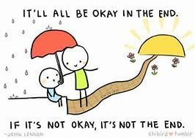

Everyone has days where they feel not okay. Some people feel not okay more often than others. The last year has been particularly tricky for many people during the pandemic, and it’s ok if you have been feeling anxious or worried about everything that has been happening. The important thing is that you, or someone who loves you, has realised that and reached out for support. There’s lots of things you can do to help yourself feel better, and there are lots of services who can support you as well.

This pack is given out by Poole Central Primary Care Network to any young person who needs a bit of help to feel okay again. Some parts of it might not be what you need, but we hope you find something helpful in here.

It includes some practical things you can do (some people call this self-care) as well as a list of NHS approved apps, websites, and leaflets from various services in the area. There is also a list of places that you might have been referred to or can refer yourself to.

Great ways to relax….
- Switch off the screens – turn off your phone, tablet and computer and go and do something that doesn’t involve tech gadgets instead like read a book, draw a picture, help cook dinner or bake a cake.
- Get a hobby– a hobby away from school can help you switch your brain off from work pressures. If you love drawing, for example, you focus on the materials rather than the piece of homework you need to finish. You’ll cope better with homework after taking a break from it.
- Aerobic Exercise – increases your heart rate and releases endorphins that make you feel good. Going to the gym, cycling, kickboxing, skateboarding, swimming or team sports such as football or netball are all great exercise. Choose one you love and build your exercise routine around that. Even a bounce on your trampoline, if you have one, is great.
- Walking– as moderate exercise, walking releases “feel good” endorphins. It can also help you to switch off - you have time to take in your surroundings and walk in a steady rhythm. Walking can be a less stressful way to travel than on a packed train or crowded bus. Fresh air helps you relax and sleep better. If you can, maybe arrange to walk to school with a friend.
- Spend time in the natural world – An old Zen proverb says: “You should sit in nature for 20 minutes a day. Unless you’re busy, then you should sit for an hour.” Combine it with exercise
and go for a walk along the beach, or try sitting in the garden.
- Yoga, tai chi and Pilates - disciplines designed around controlled movement and breathing techniques, which can aid relaxation. There are lots of free YouTube videos for beginners
- Run a warm bath–light some aromatherapy candles, run some scented bubble bath under the taps and play some chill-out music while you have a relaxing soak (Please check with your parents before lighting candles!)
- Watch a film or read a book– escapism is a great way to switch off from reality and help your mind relax. Perhaps choose something that will make you laugh.
- Meet a friend– leave a stressful situation and spend some time with a friend. Talking things over, having some laughs and hearing a different perspective can take your mind off things and help you wind down.
- Listen to music- make a playlist that shows how you feel, turn it up and dance around, share it with your friends.
- Use the app- apps like chill panda are a great way to relax at the end of the day, or when you’re feeling stressed or anxious.
- Get some sleep- change your bedding, have a shower, put some clean pj’s on and settle into bed when you’re nice and relaxed. Getting enough sleep is a key part of mental wellbeing.
- Drink more water- being well hydrated improves your mood, relieves headaches and helps you feel more energised throughout the day.
- Write down your worries- Instead of letting your worries build up all day, try writing them down. You might also want to use this as a way of telling your parents how you’re feeling. They can write in it as well, maybe something they thought you did well that day that you might have overlooked.

Local services within Dorset and Poole areas

  https://www.stormbreak.org.uk/ | An initiative developed locally in Poole aiming to improve children’s mental health through movement and helping to equip them with sustainable skills and coping strategies to thrive throughout life.
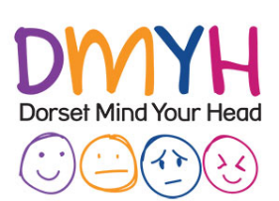  https://dorsetmindyourhead.co.uk/ | Mind provide advice and support to empower anyone experiencing a mental health problem. Local groups are available in the area for young people aged 16-25.
  ChatHealth 07480 635511  www.dorsethealthcare.nhs.uk | A confidential text messaging service that enables children and young people aged 11-19 (year 7 and above) in Dorset to send health related questions via text to the school nursing team.
CAMHS Gateway (East)  https://camhsdorset.org/young-people/ | CAMHS Dorset provides crisis support for young people in severe distress, as well as information on local services and resources. There is also a self-referral pathway for young people aged 16-18yrs.
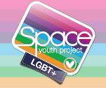  https://www.spaceyouthproject.co.uk/ | A free organisation to any young person up to the age of 25 in Dorset who is LGBT+ or unsure. Free youth groups across Dorset as well as one-to-one and family support.
Mosaic Family Support | Child Bereavement Charity | Dorset | Mosaic are a Dorset based charity supporting bereaved children and young people, their families and the professionals working with them
National Webites:
  https://www.kooth.com/ | Kooth is an anonymous site which helps children and young people to feel safe and confident in exploring their concerns and seeking professional support.
https://minds.actionforchildren.org.uk | Action for children have created a Build Sound Minds program to help parents develop the skills to talk to their child or young person about mental health, by creating a safe space for open discussion.
  https://www.samaritans.org/  Call:- 116 123 | Samaritans is a charity that provides anonymous on the phone support to anyone who needs it, 24 hours a day, every day.
  https://youngminds.org.uk/ | Young Minds is one of the leading UK charities for young people’s mental health. They have advice for teenagers and their parents on managing a wide range of problems such as bullying, anxiety and school fears
  https://www.childline.org.uk/  Call:- 0800 1111 | Childline can offer support about a wide range of problems, but they have lots of advice about eating disorders in young people. If you think you/your child has an eating disorder, please book into the surgery to discuss what support is available.
  www.MindfulMonsters.co.uk  (www.scope.co.uk) | Mindful Monsters is a subscription service that sends out mindfulness activities every month, it is aimed at primary school children and their parents to give children the skills to relax. It also helps parents begin conversations about mental health.
  www.riseabove.org.uk | Rise above is a website designed to help teenagers cope with day-to-day stresses including mental health, social media, body image, exam stress and relationships.
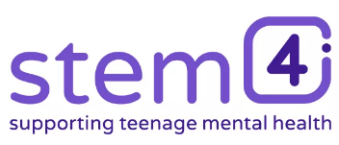  https://stem4.org.uk/ | Stem4 is a charity that promotes mental health in teenagers and those who support them, including families. Primarily provided digitally through apps and website.
  Winston's Wish - giving hope to grieving children (winstonswish.org) | Supporting children and young people after the death of a parent or sibling.
  https://www.papyrus-uk.org/ | PAPYRUS is the national charity dedicated to the prevention of young suicide.
  Pet loss support for children - missing my friend | Blue Cross | Information on supporting a child through the bereavement of losing a pet.

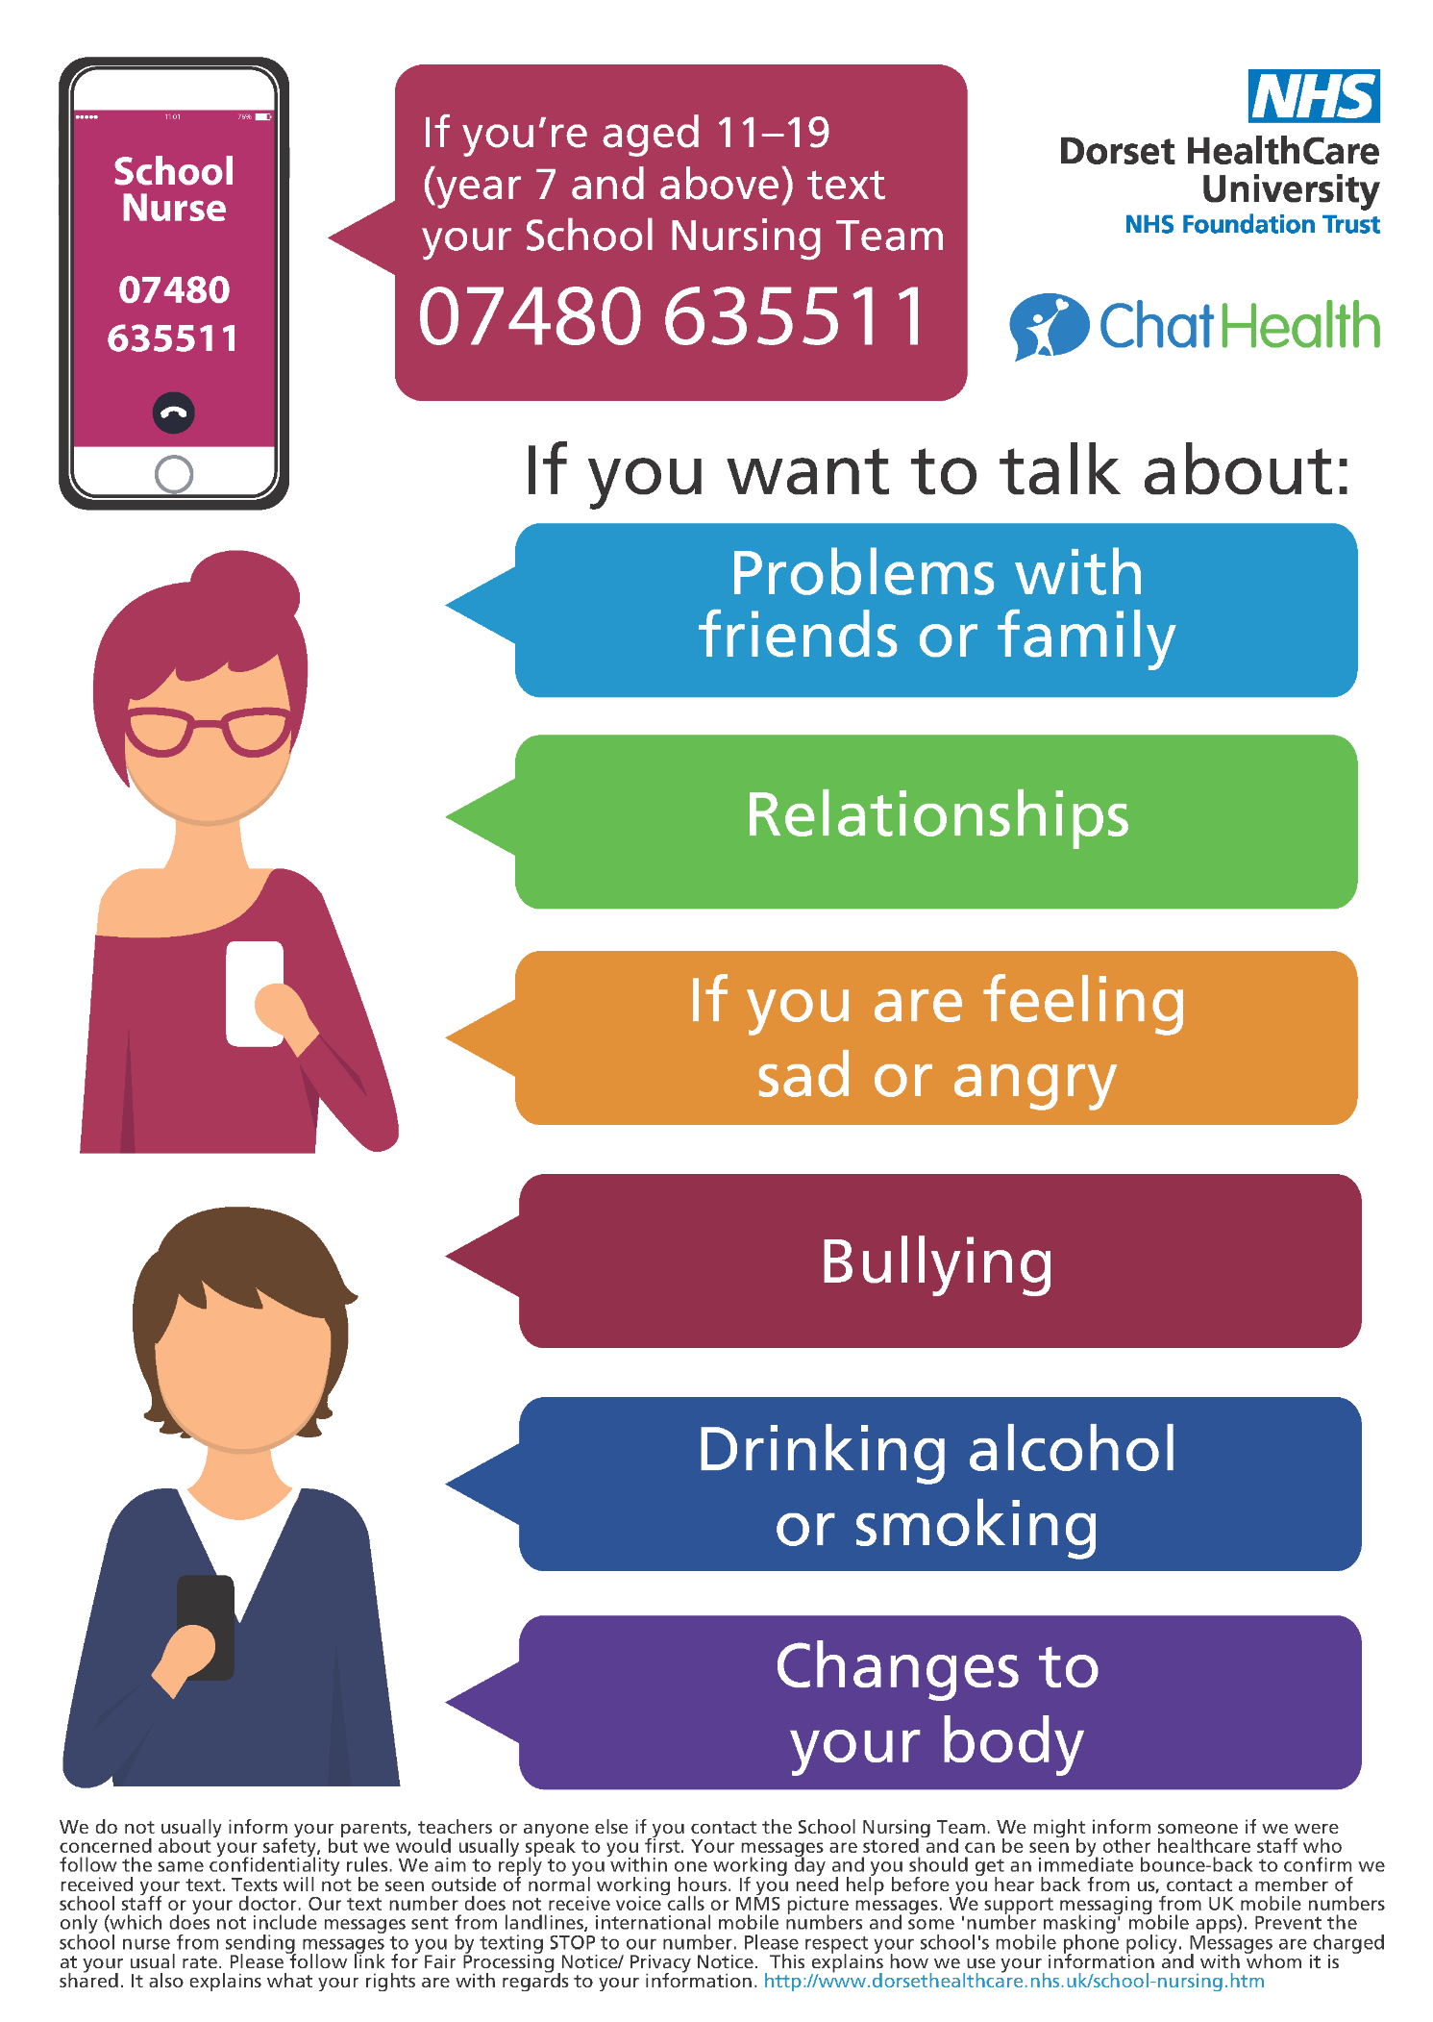

Apps for mental wellbeing
 |  | 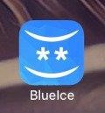 | BlueIce is an evidenced-based app to help young people manage their emotions and reduce urges to self-harm. It includes a mood diary, a toolbox of techniques to reduce distress and automatic routing to emergency numbers if urges to harm continue.
 |  |  | Calm Harm is an app designed to help people resist or manage the urge to selfharm. It’s private and password protected.
 |  |  | Chill Panda is currently being tested for NHS approval, and is an app that helps manage anxiety and worry by suggesting tasks to suit you frame of mind such as breathing techniques and gentle exercises.
 |  |  | eQuoo was designed by psychologists to give you new skills to increase your emotional fitness, communicate your feelings and maintain your mental wellbeing.
 |  |  | The MeeTwo app provides a safe and secure forum for teenagers wanting to discuss any issue affecting their lives.  You can anonymously get advice from experts or other teenagers going through similar experiences in areas such as mental health, self-harming, relationships and friendships. Every post and reply is moderated to make sure only positive feedback is published
 |  |  | The Student Health App provides easy access to more than 900 pages of reliable health information all in one place. The content has been created for university students by NHS doctors and is regularly updated.
 |  |  | Thrive helps you prevent and manage stress, anxiety and related conditions. The game-based app can be used to relax before a stressful situation or on a more regular basis to help you live a happier, more stress-free life.
 |  |  | Headspace is full of guided meditations to help manage stress, anxiety and sleep. The sessions are broken down by age.
 |  |  | Smiling mind has lots of free guided meditations to help manage stress, anxiety, sleep and the challenges of day-to-day life. There’s a youth section for under 18’s.
 |  |  | Cosmic kids is full of fun yoga and mindfulness adventure videos! It’s aimed at children aged 2 years and up.
 |  | 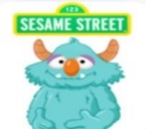 | Breathe, think, do with Sesame street is aimed at children aged 2-5 years old, and teaches skills like solving everyday challenges, planning and managing emotions.
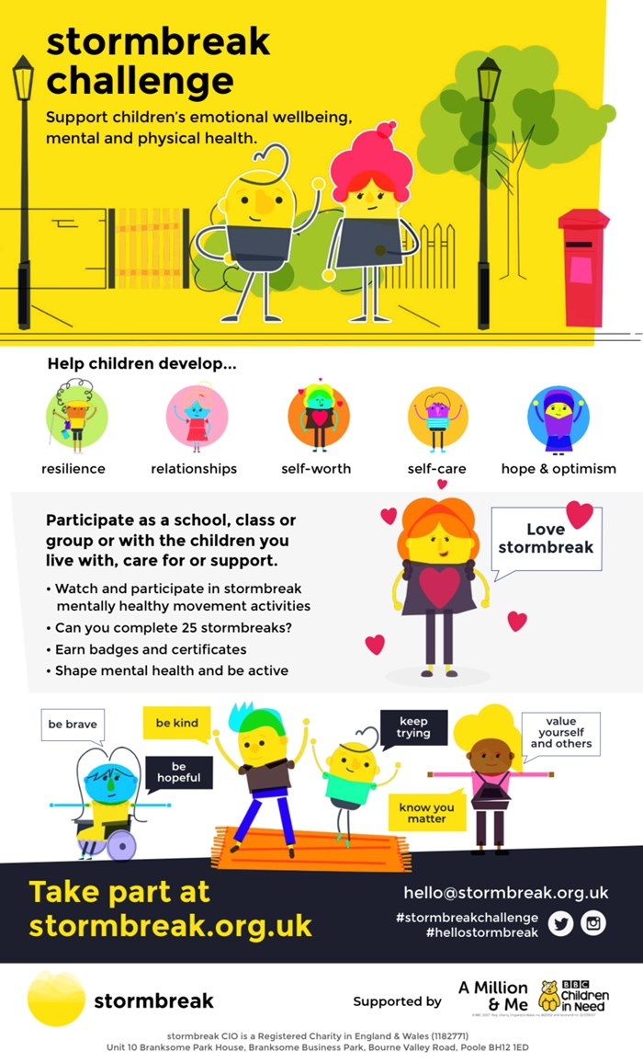
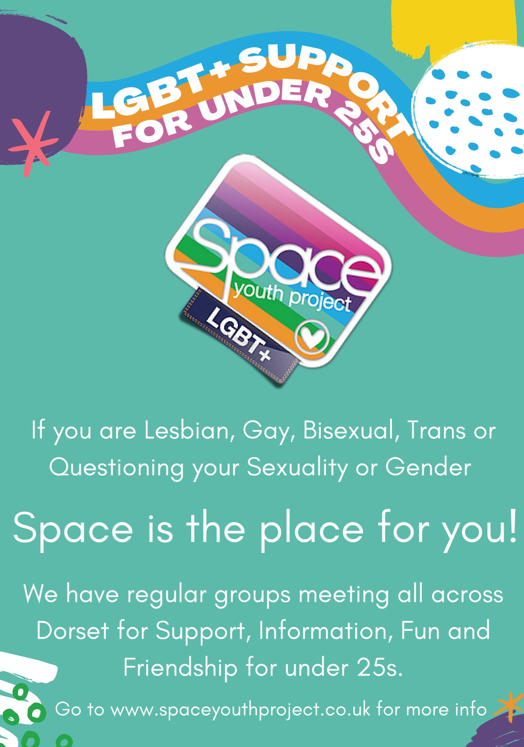
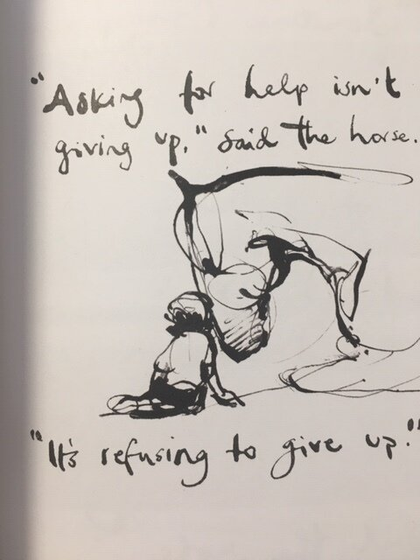
The Boy, the Mole, the Fox and the Horse by Charles Mackesy
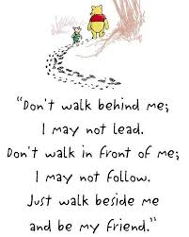
Book by Charlie Mackesy

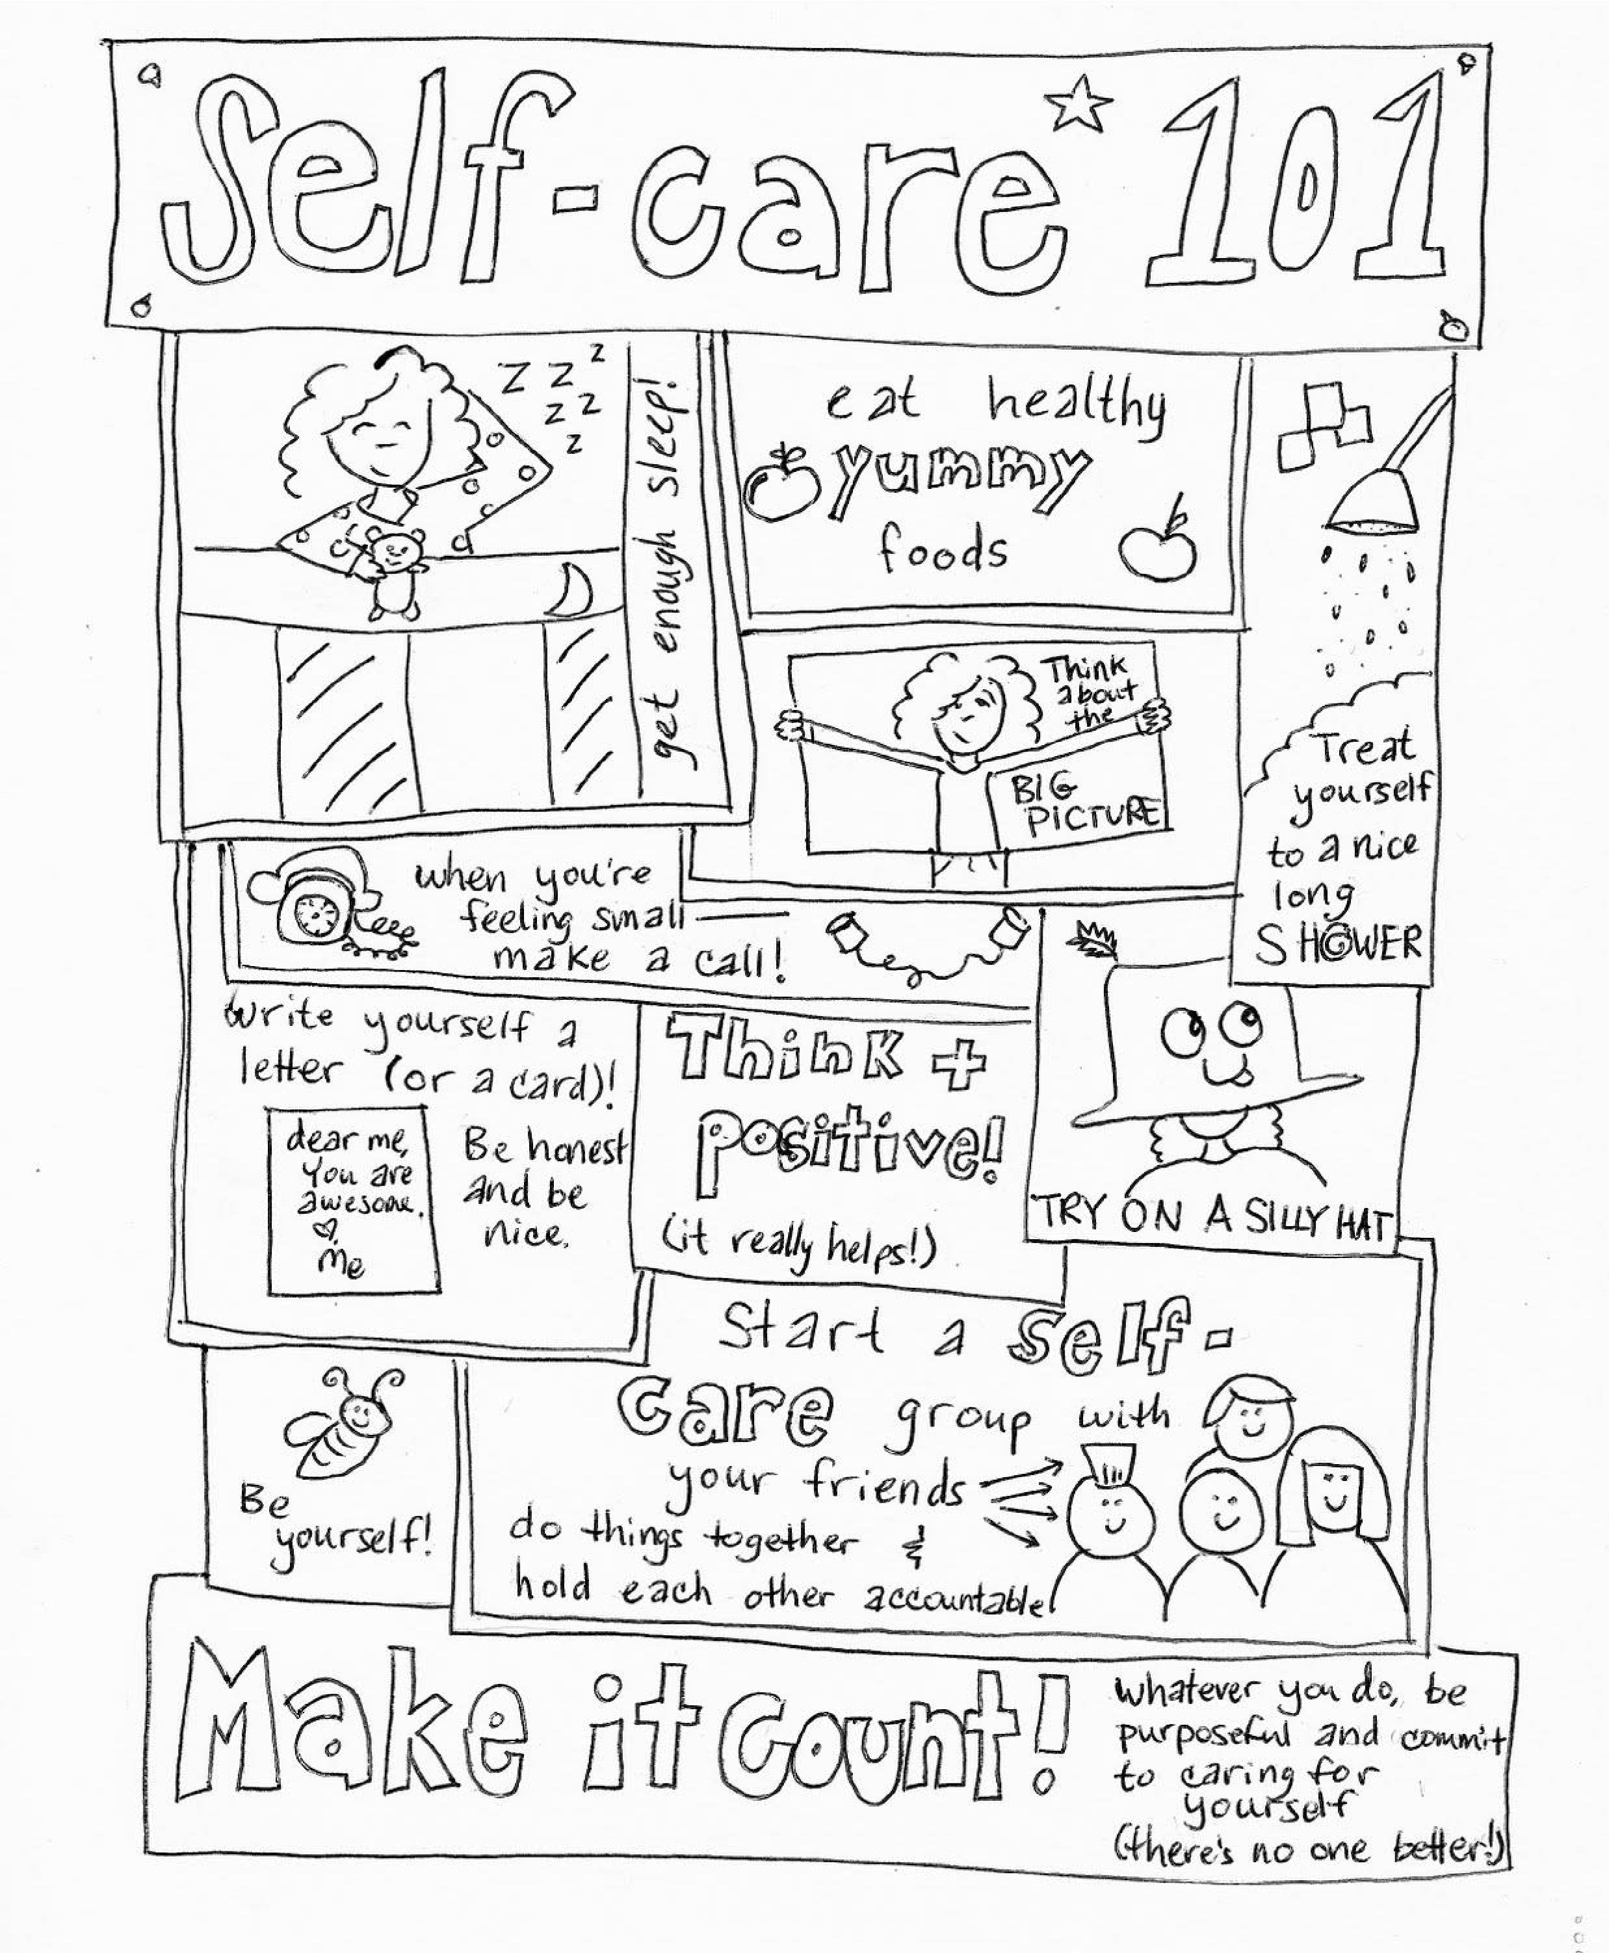


Why not try

some colouring

to relax
?

Sample of books

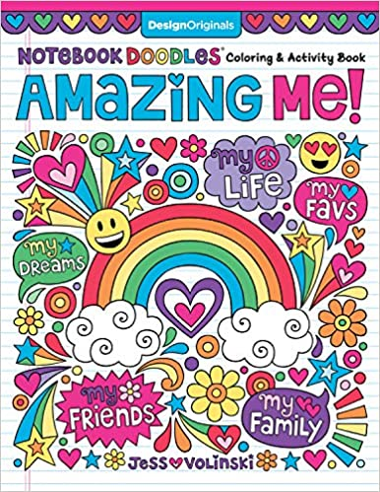
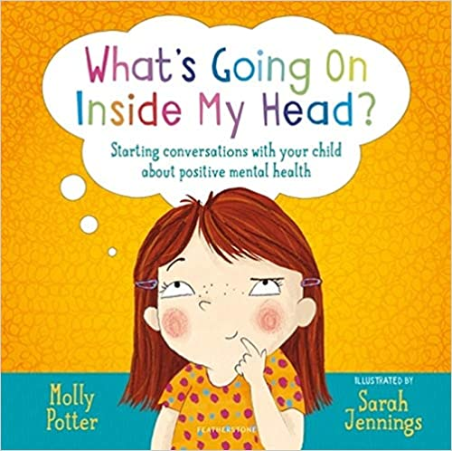
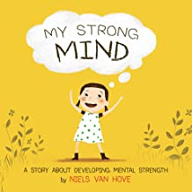
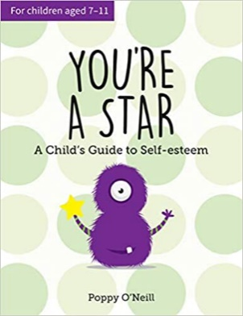
“This practical guide combines proven cognitive-behavioural therapy methods used by child psychologists in schools with simple activities to help your child grow their self-esteem. It’s aimed at children aged 7–11 because a lot happens in these years that can impact a child’s sense of self-worth, not just now but for years to come.”

“Teach your children about Confidence, Resilience and a Growth Mindset. With My Strong Mind your children will be introduced to mental strength and learn social skills and techniques to develop their own strong mind.”

“By talking about positive self-image, emotional intelligence, relationships and mindfulness, this book will help children develop healthy habits and good coping strategies from the start.”

“Notebook Doodles Amazing Me! is packed with empowering art activities designed to build confidence and self-esteem”

A story about the loss of a much-loved pet.

